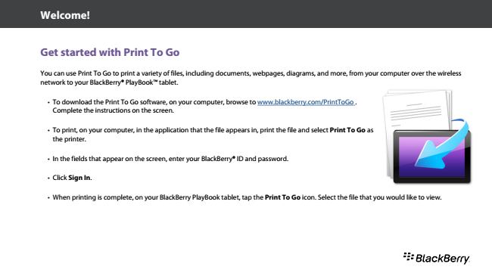

**Welcome!**

**Get started with Print To Go**

You can use Print To Go to print a variety of files, including documents, webpages, diagrams, and more, from your computer over the wireless network to your BlackBerry® PlayBookTM tablet.

• To download the Print To Go software, on your computer, browse to www.blackberry.com/PrintToGo . Complete the instructions on the screen.

• To print, on your computer, in the application that the file appears in, print the file and select Print To Go as the printer.

• In the fields that appear on the screen, enter your BlackBerry® ID and password.

• Click Sign In.

• When printing is complete, on your BlackBerry PlayBook tablet, tap the Print To Go icon. Select the file that you would like to view.